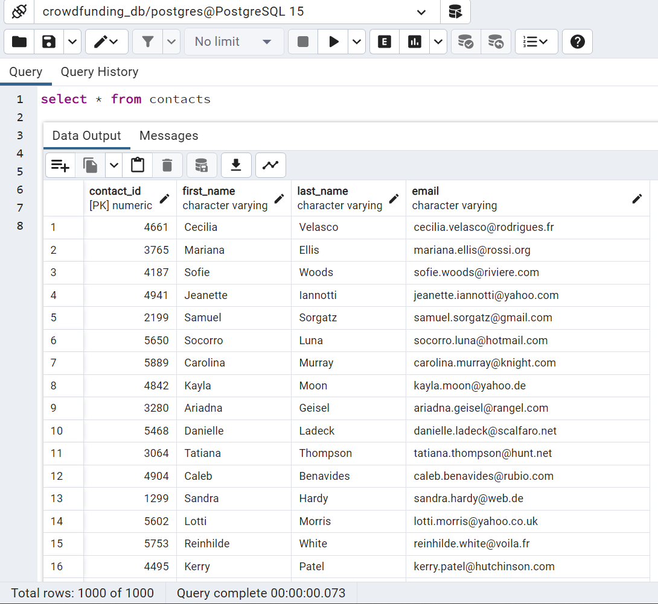

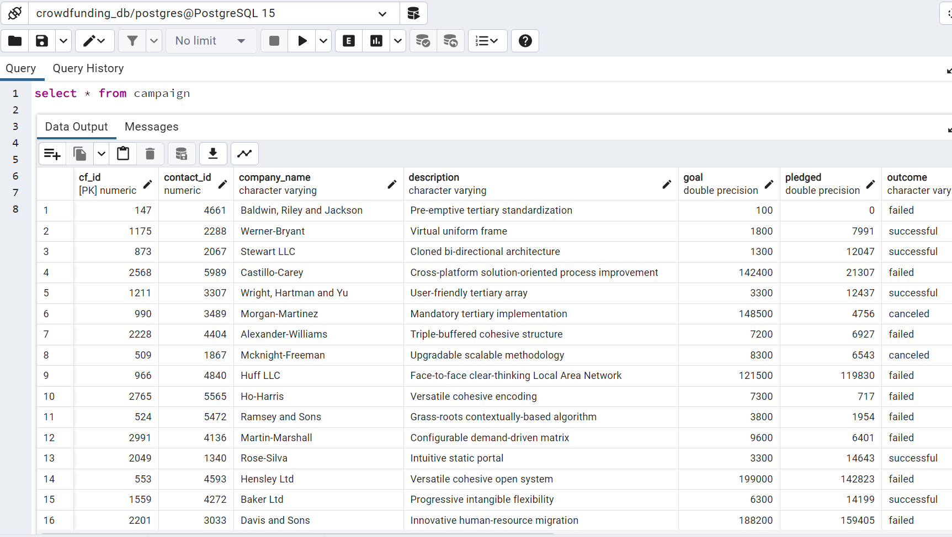

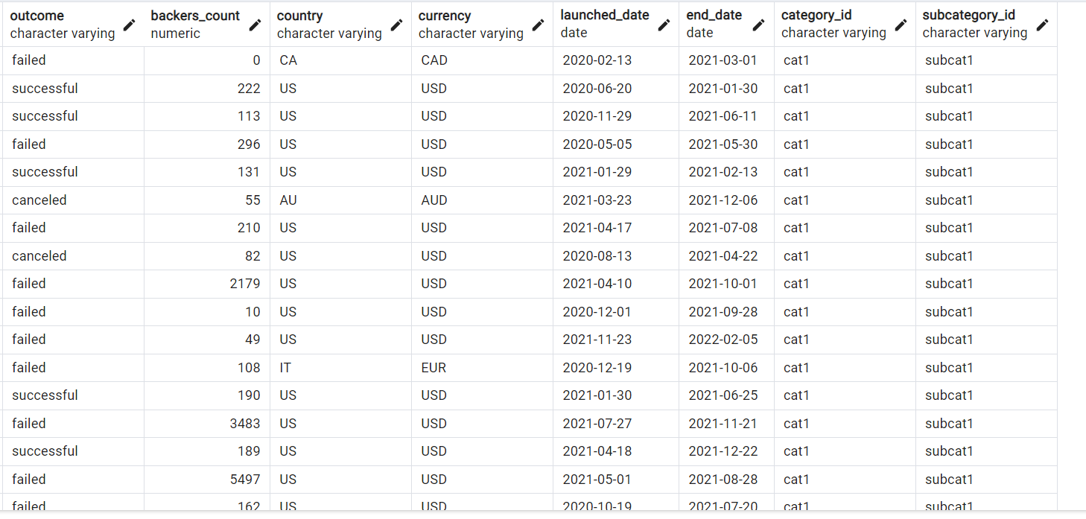

An SQL across the entire database, retrieving successful campaign results.

SELECT

a.company_name, a.currency, a.pledged, a.outcome, a.end_date,

b.category, c.subcategory,

d.first_name, d.last_name, d.email

FROM campaign a

LEFT JOIN category b on a.category_id = b.cat_id

LEFT JOIN subcategory c on a.subcategory_id = c.subcategory_id

LEFT JOIN contacts d on a.contact_id = d.contact_id

WHERE a.outcome = ('successful')

ORDER BY a.Currency, a.pledged DESC



